Operations Manual for Improved Finger Followers Staking Mechanism
Designed for GT Technologies

Patrick Landy Brian Webb Jarrel Williams Jaron Zadi

March 29, 2008

Table of Contents
1.0 General Safety steps 3
2.0 operation steps for staking 4
3.0 OPeration steps for staking depth testing 9
4.0operation steps for torque turn testing 11
5.0 OPeration steps for punch-out testing 13

General Safety Steps:
- Ensure the following safety equipment is equipped properly.
  - Protective eye wear
  - Ear plugs
  - Steel-toe shoes
  - Remove all loose clothing and jewelry
- Prior to operation know were the following is located.
  - Emergency Exit
  - Fire Extinguisher
- Follow and understand signs as shown is figure A


Figure A: ISO 3864 safety sign formats (clockwise from top left): warning sign, prohibition sign, mandatory action sign, and safety information sign.

Operations Steps for Staking:
This manual is for the safe operation of the chuck design finger follower staking machine, figure B. To operate the staking machine it is important to know how it works. The driving force behind the staking process is hydraulic fluid. The hydraulic fluid powers a cylinder which pushes down on the chuck via a connecting rod. The staking tools are attached to the chuck, so when the chuck is open the staking tools closes and stakes the part.

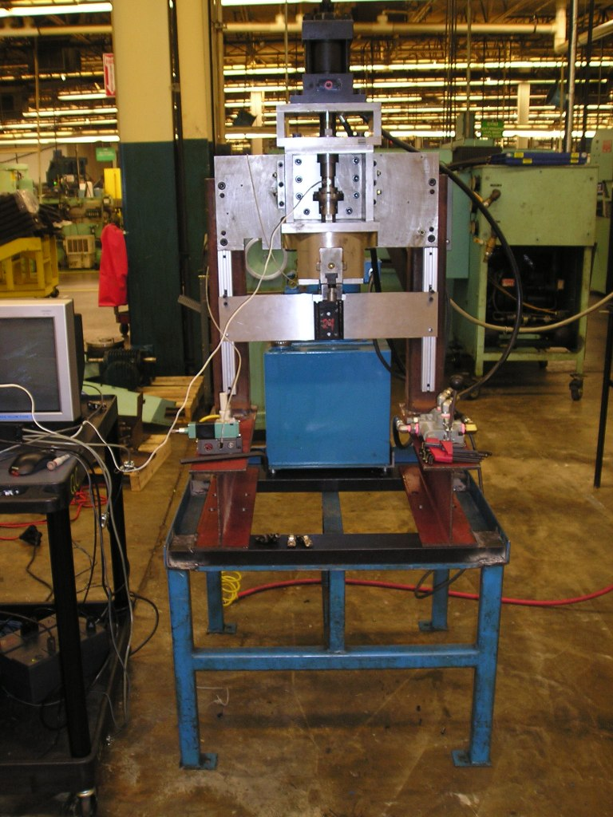
Figure B: Overview of the staking machine

1. Check the machine to make sure it is ready for operation:
- Check all the hydraulic lines for leaks and that they are all connected
- Check the air line to make sure they are properly connected.
- Check to ensure the machine has a power line connected
- Now that the machine is readily for operation and the work environment is safe locate the finger follower for staking.
- Position the finger follower in the nest (figure C)
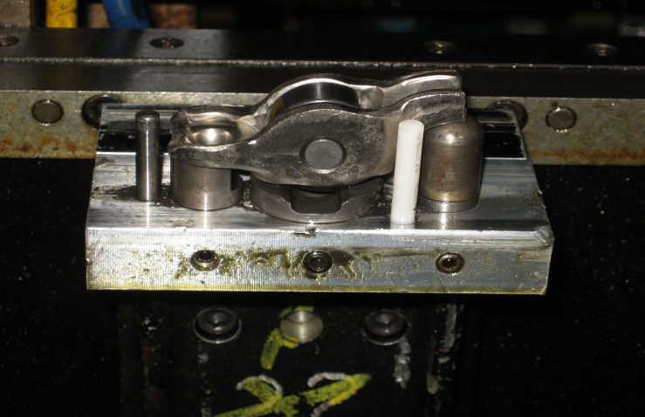
Figure C: Finger Follower Position in the nest
- Raise the back plate which the nest is attached to until it hits the stoppers. Ensure that the axel for the finger follower is positioned directly between the two staking tools, figure D. If so then tighten the bolts and lock the nest in place.
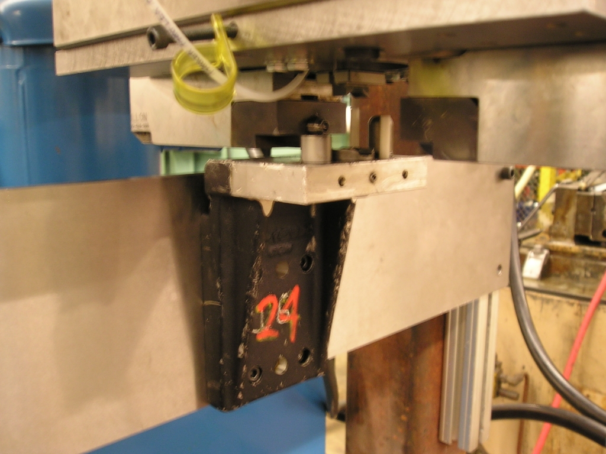
Figure D: Correct Placement of the Nest

- Locate the controls on the left side of the machine, figure E.
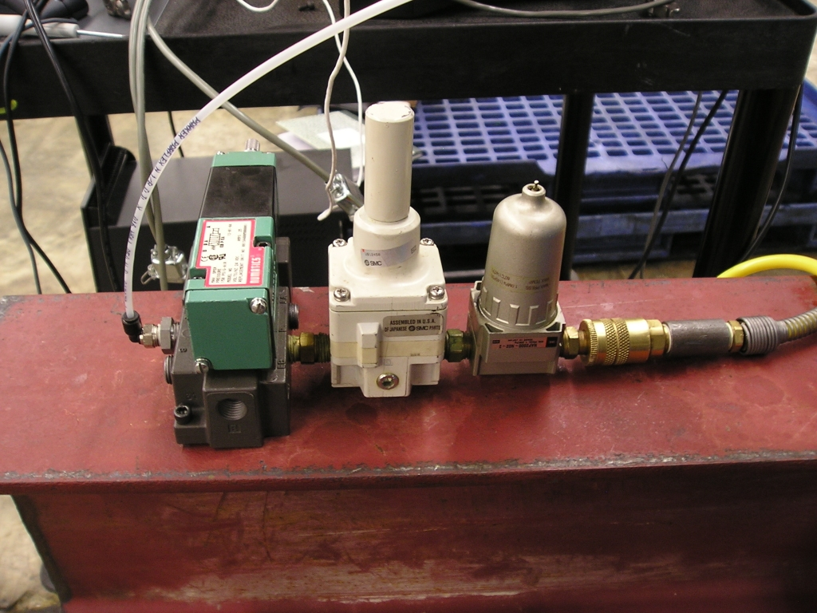
Figure E: Pneumatic Cylinder Controls
These controls power a Pneumatic cylinder. To ensure the finger follower stays in the correct position a V-block is positioned using the pneumatic cylinder. It pushes down on the finger follower (figure F) locking the follower in position.
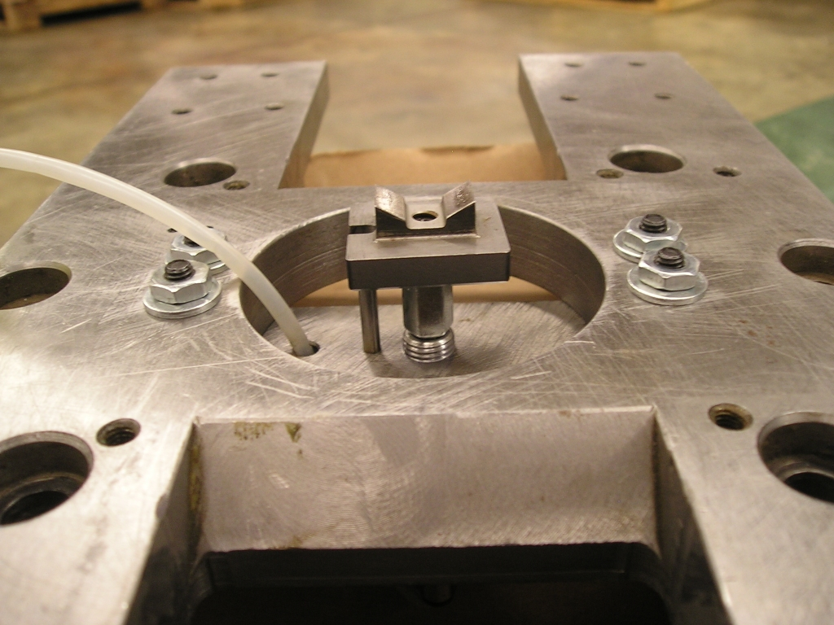
Figure F: The V-block
- Locate the controls on the right side of the machine (figure G). This is the controls which power the hydraulic cylinder. The controls are simple, pull down to stake the part and push up to release it.
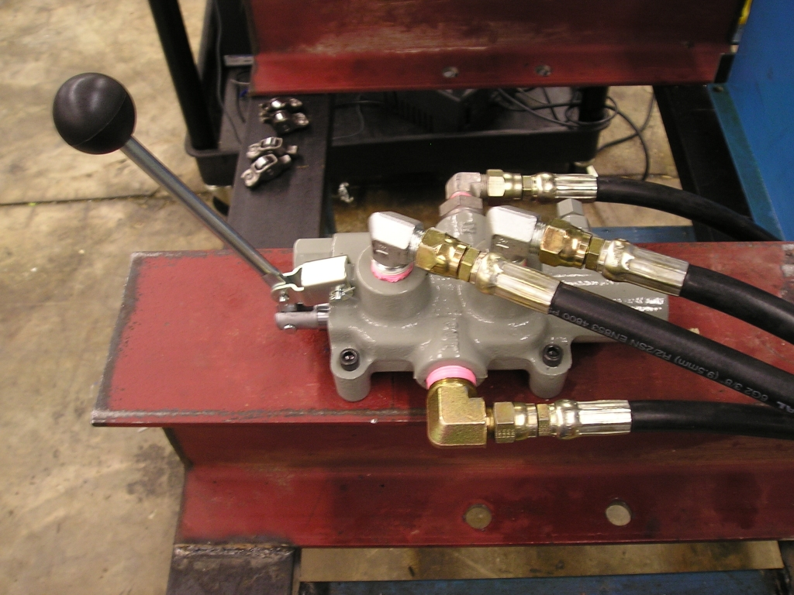
Figure G: Hydraulic Controls
IMPORTANT: When not operating leave the lever in the neutral position to avoid building up to much pressure which could result in serious injury.
- Now that all the functions of the machine have been explained turn the machine on. This is done by the control panel located on the back of the machine.
- Push up on the hydraulic controls to ensure the staking tools are not closed.
- Use the controls for the pneumatic cylinder to extend the V-block. This is done by pushing the button shown in figure H. The button can be locked by pushing and then rotating until locked.
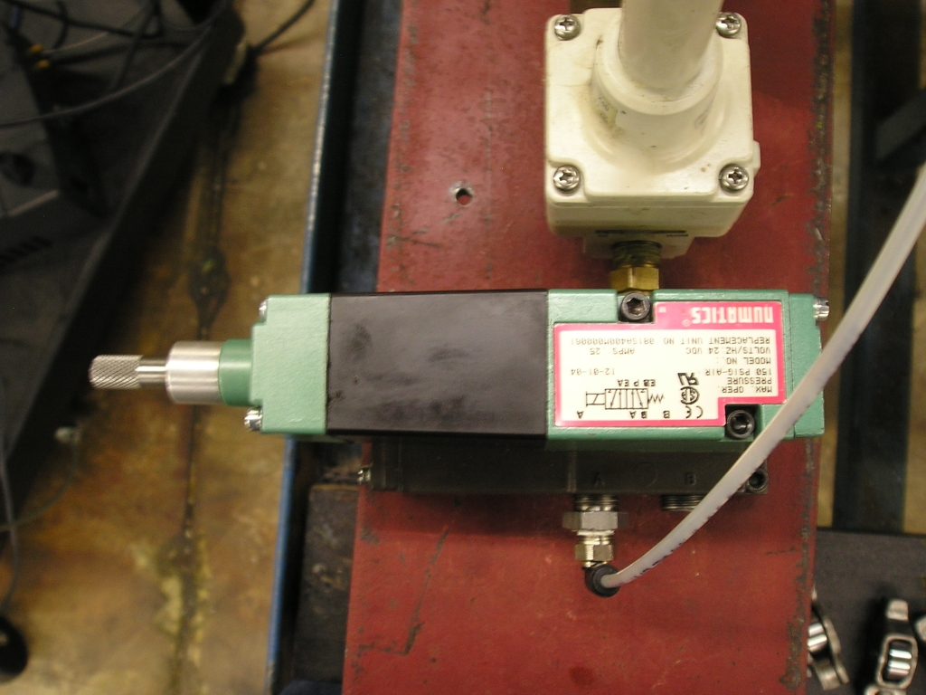
Figure H: Pneumatic Controls
- Now the part is secure. Ensure everything is clear of the staking tools, pull down on the hydraulic controls and stake the part. After the staking tools stop moving or a few seconds push up on the hydraulic controls and stop the staking. Ensure the lever is put back into the neutral position.
- Turn the machine off.
- Disengage the pneumatic cylinder to release the finger follower from the V-block.
- Lower the black plate the nest is attached to.
- Remove the newly staked finger follower and repeat as needed.

Operations Steps for Staking Depth Testing:

This test is to determine the staking depth. The acceptable range for staking is 0.2-0.4mm. If the staking depth is too deep then the axel could be deformed and potentially seize up. If the staking depth is not deep enough then it would be possible for the axel to come out. This testing, tests the depth of the stake relative to the unstaked portion of the axel.

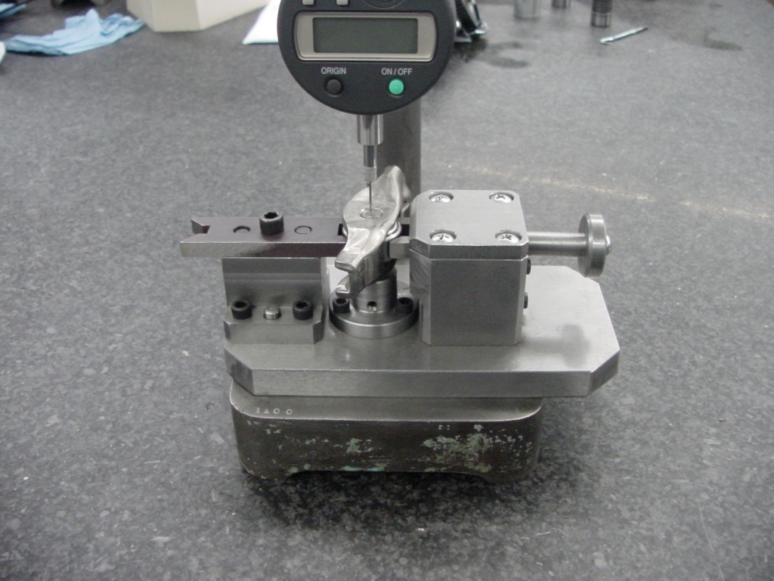
Figure I: Depth Micrometer

    - Check the depth micrometer to ensure it has power.
    - Place the finger follower into the clamp.
    - Place finger follower in the clamp so that the unstaked axel is directly under the micrometer
    - Zero out the micrometer
    - Move the finger follower so the micrometer is position inside the grove created from staking.
    - Record the result
    - Move to another location in the grove and record
    - Repeat multiple times to come up with an average.
    - Flip the finger follower over and repeat steps 2-8.
    - Compare the averages to the acceptable range and determine if the part passed or failed.

Operations Steps for Torque to Turn Testing:

This test is to determine the torque needed, in inch lbs, to rotate the axel of the finger follower. The ideal range for the torque is 100-160 inch lbs. If the finger follower is under torque then the part will fail because the axel will not stay in position properly through the repeated rotations in the engine. If the torque is too large the finger follower can seize up in the engine.
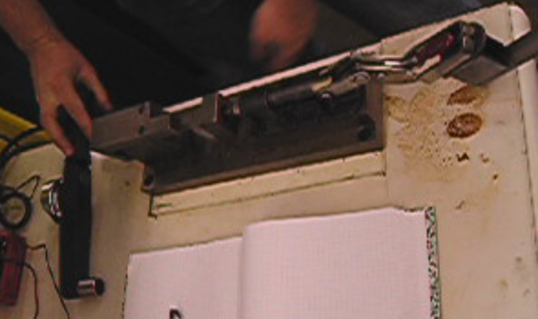
Figure J: Torque to Turn Testing Apparatus
- Position the finger follower so the axel is located in between the two clamps.
- Raise the handle and push until closed and the part is locked in place.
- Now the part in locked into place the testing can begin. Locate the torque wrench, figure K.
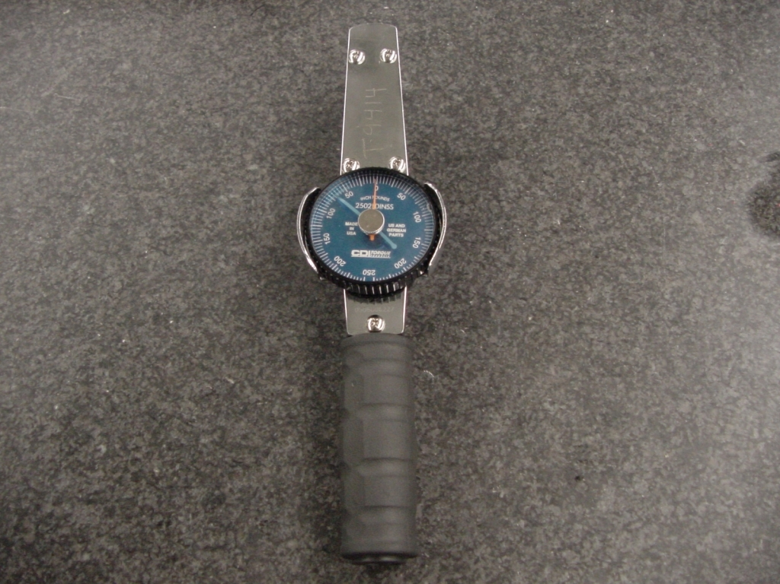
Figure K: Torque Wrench
- Spin the knob on the wrench until both the blue tack and red tack are on the zero position.
- Position the torque wrench so it is attached to the testing block and flush with the table
- Pull the wrench back gently and smoothly until it at 90º. IMPORTANT do not jerk the wrench because it will throw off the readings.
- Lift the handle and release the part.
- Check the part against the acceptable range and determine if it passed or failed.

Operations Steps for Push-Out Testing:

The purpose of this test is to determine the force required to push-out, remove, the axel from the finger follower. The force required to knock the axel out is an indicator of how well the axel is staked in place. If the force is low then the axel could potentially come out, to high and it could seize up the follower. The acceptable range is 2500-3250 lbs.
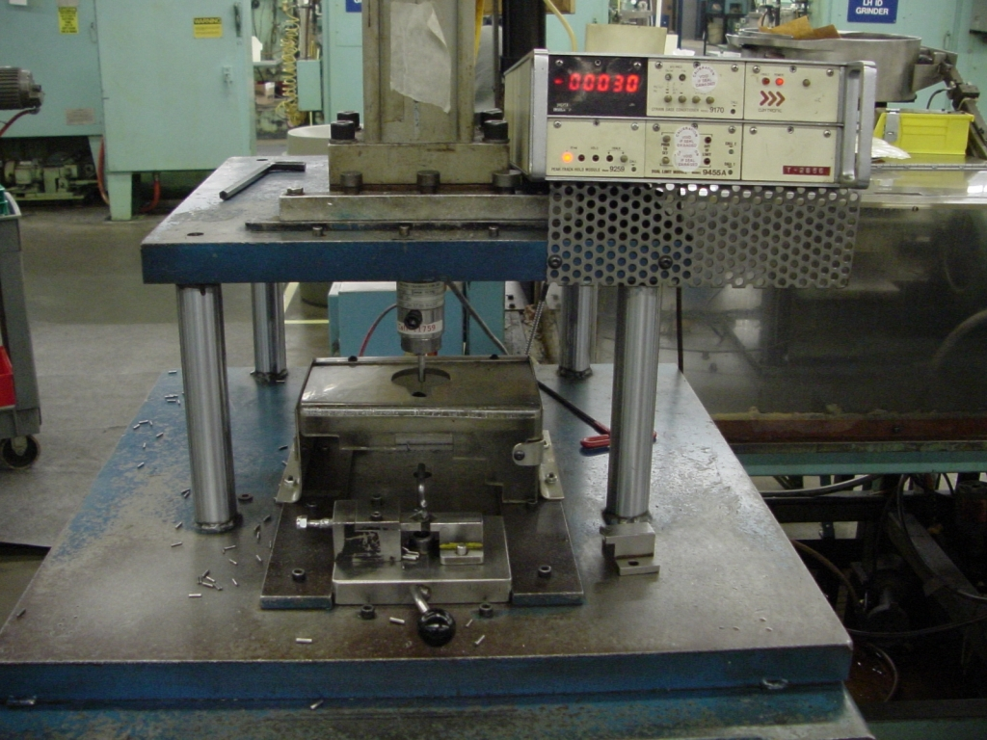
Figure K: Push-Out Testing Machine

IMPORANT: This machine is very powerful care must be taken to stay safe. Never place you hand into the shielded region of the tool.
- Using the extraction tool, remove all the debris from the shielded region of the machine.
- Position the finger follower into the clamp
- Zero out the computer and have it set to record the highest value
- Slide the clamp with the finger follower into position.
- Check to make sure the machine is clear
- Using both hands activate the machine. Both buttons must be pressed simultaneously in order to work.
IMPORTANT: keep both hands on the buttons until the test is over. Premature removal of you hands will cut off the machine.
- Slide the clamp out remove your part
- Clean up the debris

